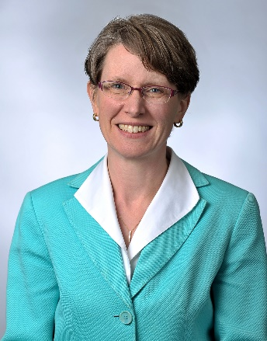
The Lake County Estate Planning Council
September 12, 2019 – 12:00pm at The Lake Forest Club
The Lake County Estate Planning Council welcomes Kristin Carlson Vogen, Senior Director of philanthropic services at The Chicago Community Trust.
Vogen and her team engage families and individuals to focus their giving for impact and develop collaborative philanthropy strategies; leverage the knowledge of the Trust’s community impact staff for the benefit of donor advisors; and enhance opportunity for impact investing. Prior to joining the Trust in 2018, Vogen was president and CEO of the Oak Park-River Forest Community Foundation, and previously worked at Bank of America/U.S. Trust as a philanthropic specialist. Throughout her career, Vogen has provided subject matter expertise to individuals and families on private foundations, donor advised funds and endowment management for public charities.
Presently, Vogen is a board member of Cara Chicago and a trustee of Window to the World Communications, Inc. (WTTW 11/WFMT 98.7). She is a member of the Planned Giving Advisory Committee for WTTW/WFMT as well. Vogen has served as adjunct professor at Concordia University Chicago, teaching in its Not-For-Profit Program. She is a frequent speaker for Chicago Council on Planned Giving and other area philanthropic groups. Vogen was named 2015 River Forest Villager of the Year by the Wednesday Journal for her work with the OPRF Community Foundation. In 2015 she was the inaugural recipient of the ALDE (Association of Lutheran Development Executives) Chicago Chapter Outstanding Leader Award. In 2016, Vogen and the OPRF Community Foundation received the Scott Gaalaas YMCA Partnership Award from the West Cook YMCA.
Vogen earned her J.D. from William Mitchell College of Law, and her B.B.A. in Human Resource Management from Abilene Christian University.
Vogen and her team work in cooperation with the staff of The Lake County Community Foundation, the local geographic affiliate of The Chicago Community Trust, based in Waukegan and under the Executive Director leadership of Maggie Morales.

